**113EC0199 SAGNIK BASU**

### Channel Equalization using MLP

**Matlab Code :**

**clc;**

clear all;

close all;

c=input('Channel order');

experiments =50.0;

%noise=2*rand(1,samples)-1; %%noise(bias)

%%channel 1

%y1=inp+noise;

samples=1000;

x=2*rand(1,samples)-1;

inp=zeros(1,samples);

inp=zeros(1,samples);

for i=1:length(x) %%generation of inputs

if(x(i)<0)

inp(i)=-1;

else if(x(i)>0)

inp(i)=1;

else

inp(i)=0;

end

end

end

SNR=5;

%y1=awgn(inp,SNR);

y2=[inp(2:length(inp)) inp(1)];

y4=[inp(3:length(inp)) inp(1:2)];

y3=(0.364*inp)+(0.86*y2)+(0.364*y4);

r=awgn(y3,SNR);

%weights=2*(rand(1,c))-1;

%bias=2*rand(1,1)-1; %%bias for the perceptron

weights=-1+2.*rand(2,2*c);

weights_b= -1+2.*rand(1,2*c);

weightsb_out= -1+2.*rand(1,1);

bias = [-1 -1 -1 -1 ];

%iterations = constant;

coeff=0.5;

y=zeros(1,samples);

output=zeros(1,samples);

error=zeros(1,samples);

err_train=zeros(1,samples);

%%final_err_train=0;

for j=1:samples-c

%% input1(:,j)=input(:,r);

% y(1,j)=y1(1,j:j+c-1)*(transpose(weights))+bias;

%%out(1,j) = (1/(1+exp(-y(1,j))));

%%e=d_out(r)-out(j);

%output(1,j)=hardlims(y(1,j));

%MSE Calculation for 50 experiments

final_err_mse2=0;

H1 = bias(1,1)*weights_b(1,1)+r(1,j)*weights(1,1)+ r(1,j+1)*weights(1,2);

% Send data through sigmoid function 1/1+e^-x

% Note that sigma is a different m file

% that I created to run this operation

x2(1) = tanh(H1);

H2 = bias(1,2)*weights_b(1,2) + r(1,j)*weights(1,3) + r(1,j+1)*weights(1,4);

x2(2) = tanh(H2);

%H3 = bias(1,3)*weights_b(1,3) + x(i)*weights(1,5) + y(i)*weights(1,6);

%x2(3) = tanh(H3);

%H4 = bias(1,4)*weights_b(1,4) + x(i)*weights(1,7) + y(i)*weights(1,8);

%x2(4) = tanh(H4);

%H2 = bias(1,4)*weights(1,4) + x(i)*weights(2,2) + y(i)*weights(2,3);

%x2(3) = tanh(H2);

% Output layer

x3_1 = bias(1,4)*weightsb_out(1,1)+ x2(1)*weights(2,1)+x2(2)*weights(2,2);%+x2(3)*weights(2,3);%+x2(4)*weights(2,4);

out(j) =tanh(x3_1);

for k=1:experiments

y_mse2(1,k)=bias(1,4)*weightsb_out(1,1)+ x2(1)*weights(2,1)+x2(2)*weights(2,2);

output_mse2(1,k)=tanh(y_mse2(1,k));

error_mse2(1,k)=inp(1,k)-output_mse2(1,k);

final_err_mse2=final_err_mse2+error_mse2(1,k)*error_mse2(1,k);

end

mse_2(j)=final_err_mse2/experiments;

delta3_1 = (1-out(j)*out(j))*(inp(j)-out(j));

%delata3_1=(output(i)-out(i));

% Propagate the delta backwards into hidden layers

%delta2_1 = x2(1)*(1-x2(1))*weights(3,2)*delta3_1;

%delta2_2 = x2(2)*(1-x2(2))*weights(3,3)*delta3_1;

delta2_1 = (1-x2(1)*x2(1))*weights(2,1)*delta3_1;

delta2_2 = (1-x2(2)*x2(1))*weights(2,2)*delta3_1;

% delta2_3 = (1-x2(2)*x2(2))*weights(2,3)*delta3_1;

weights_b(1,1) = weights_b(1,1) + coeff*bias(1,1)*delta2_1;

weights_b(1,2) = weights_b(1,2) + coeff*bias(1,2)*delta2_2;

%weights_b(1,3) = weights_b(1,3) + coeff*bias(1,3)*delta2_3;

%weightsb(1,4) = weightsb(1,4) + coeff*bias(1,4)*delta2_4;

weightsb_out = weightsb_out + coeff*bias(1,4)*delta3_1;

weights(1,1) = weights(1,1) + coeff*r(1,j)*delta2_1;

weights(1,2) = weights(1,2) + coeff*r(1,j+1)*delta2_1;

weights(1,3) = weights(1,3) + coeff*r(1,j)*delta2_2;

weights(1,4) = weights(1,4) + coeff*r(1,j+1)*delta2_2;

weights(2,1) = weights(2,1) + coeff*x2(1)*delta3_1;

weights(2,2) = weights(2,2) + coeff*x2(2)*delta3_1;

%%training

%error(1,j)=inp(1,j)-output(1,j);

%%err_train(j)=error(1,j)*error(1,j);

%bias=bias+error(1,j);

%weights=weights+error(1,j)*y1(1,k:k+c-1);

%weights_array(j,:)=weights;

%%weights_final(j,:,k)= weights;

%%bias_final(j,1,k) = bias;

%%error(j,1,k) = e;

end

%%Testing

testing_size=1000;

y_test=2*rand(1,testing_size)-1;

input=zeros(1,50);

final_err=0;

mse=zeros(1,50);

SNR=1;

for k=1:100

y_test=2*rand(1,testing_size)-1;

input=zeros(1,testing_size);

for i=1:length(y_test) %%generation of inputs

if(y_test(i)<0)

input(i)=-1;

else if(y_test(i)>0)

input(i)=1;

else

input(i)=0;

end

end

end

final_err=0;

SNR_arr(k)=SNR+k/10;

y1=awgn(input,SNR_arr(k));

BER=0;

for i=1:testing_size-c+1

% y1_test(1,i)=y1(1,i:i+c-1)*(transpose(weights))+bias;

% percp_out(1,i)=hardlims(y1_test(1,i));

% error_test(i)=percp_out(1,i)-input(1,i);

H1 = bias(1,1)*weights_b(1,1)+y(1,j)*weights(1,1)+ y(1,j+1)*weights(1,2);

% Send data through sigmoid function 1/1+e^-x

% Note that sigma is a different m file

% that I created to run this operation

x2(1) = tanh(H1);

H2 = bias(1,2)*weights_b(1,2) + y(1,j)*weights(1,3) + y(1,j+1)*weights(1,4);

x2(2) = tanh(H2);

x3_1 = bias(1,4)*weightsb_out(1,1)+ x2(1)*weights(2,1)+x2(2)*weights(2,2);%+x2(3)*weights(2,3);%+x2(4)*weights(2,4);

out(i) = hardlims(tanh(x3_1));

error_test(i)=out(1,i)-input(1,i);

if(error_test(i)==0)

else

BER=BER+1;

end

end

%final_err=final_err+error_test(i)*error_test(i);

BER_arr(k)=BER/1000;

end

%mse(k)=final_err/1000.0;

%axis([-3 3 -3 3]);

%w1=-bias/weights(1,1);

%w2=-bias/weights(1,2);

%plot([w1,0],[0,w2]);

%hold on;

%plotpv(inp,inp);

%hold on;

%plotpc(weights,bias);

**BER Curves for delay elements(-2/-3/-4)**

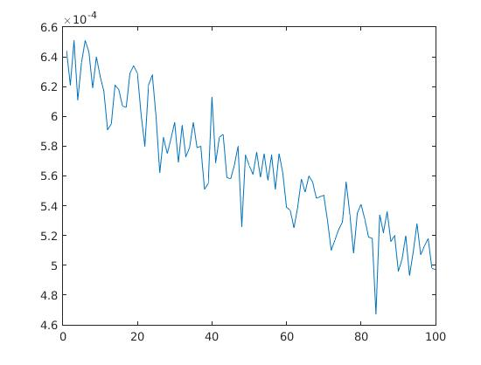

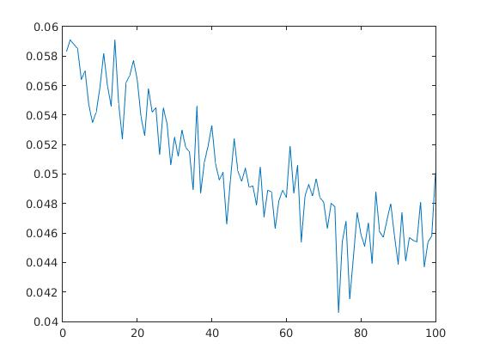

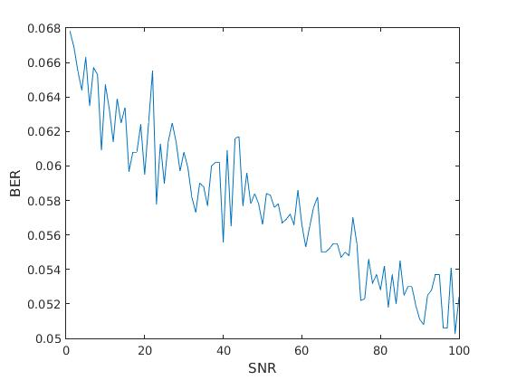

**MSE curves for different channel models using 2 hidden layers**

**a) y(n) = x(n) + 0.5x(n − 1) + N(n)**

**b) y(n) = 0.5x(n) + x(n − 1) + N(n)**

**c) y(n) = 0.364x(n) + 0.86x(n − 1) + 0.364x(n − 2)**

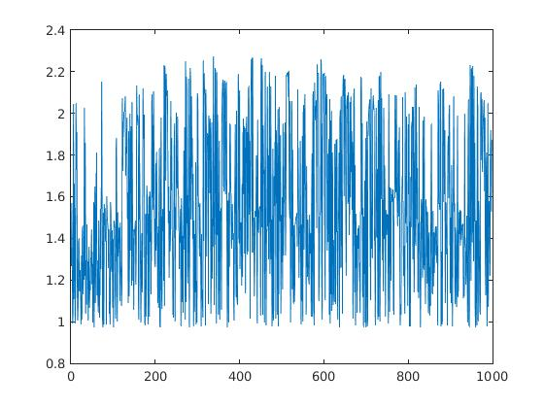

**a)**

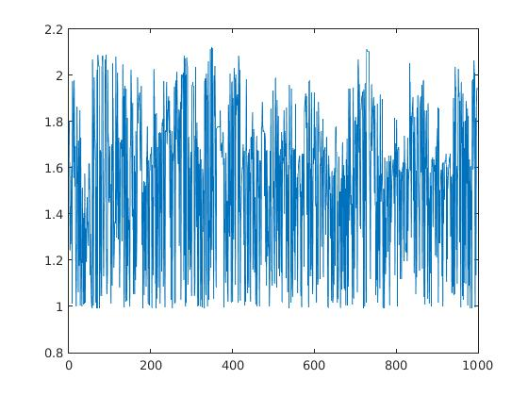

**b)**

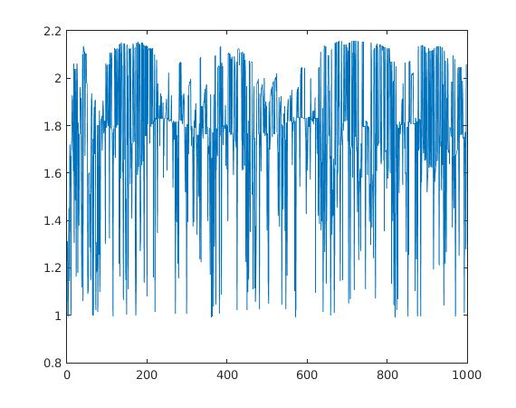

**c)**